IAM-Role task  
  
  
1) Create one IAM user and assign ec2,s3 full access role.  
  
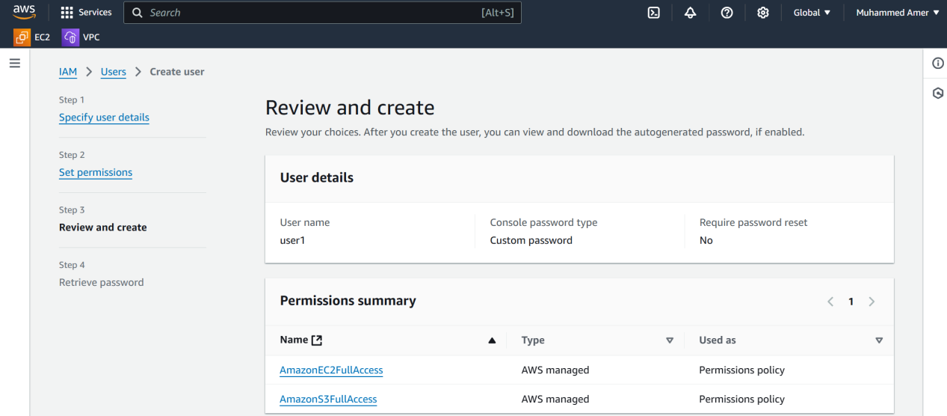  
  
  
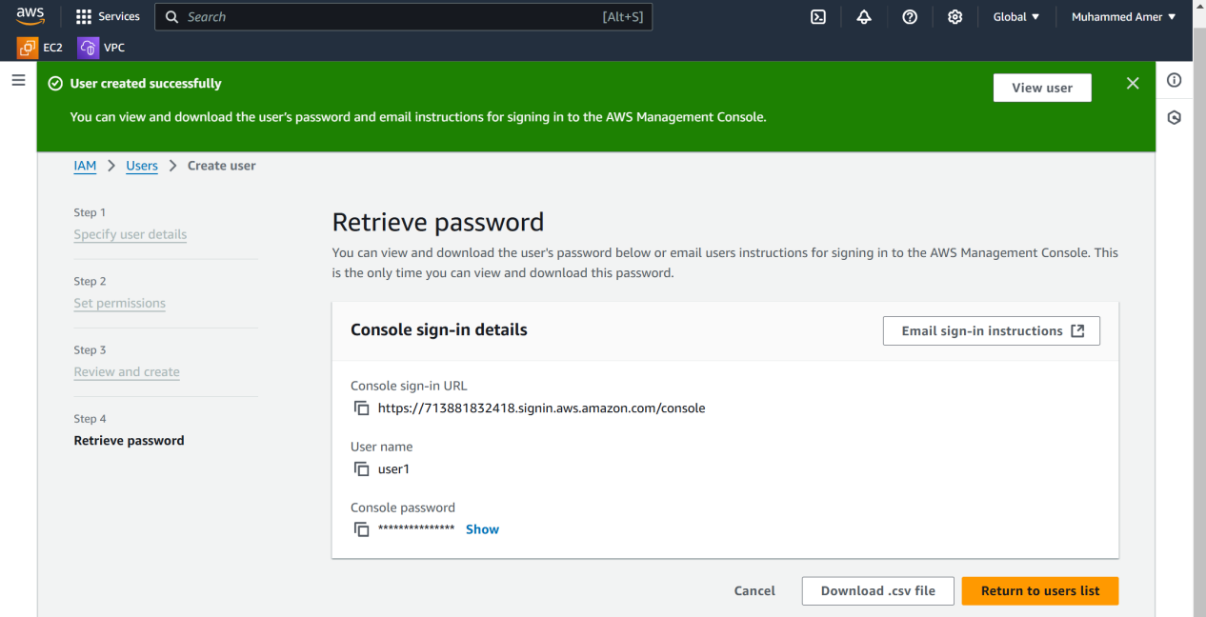  
  
  
  
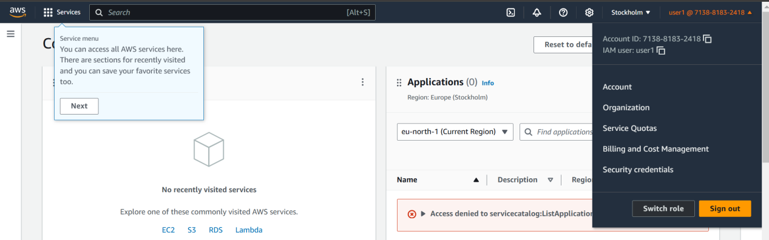  
  
  
2) Create one Group in IAM and Assign Read access for ec2.   
  
  
  
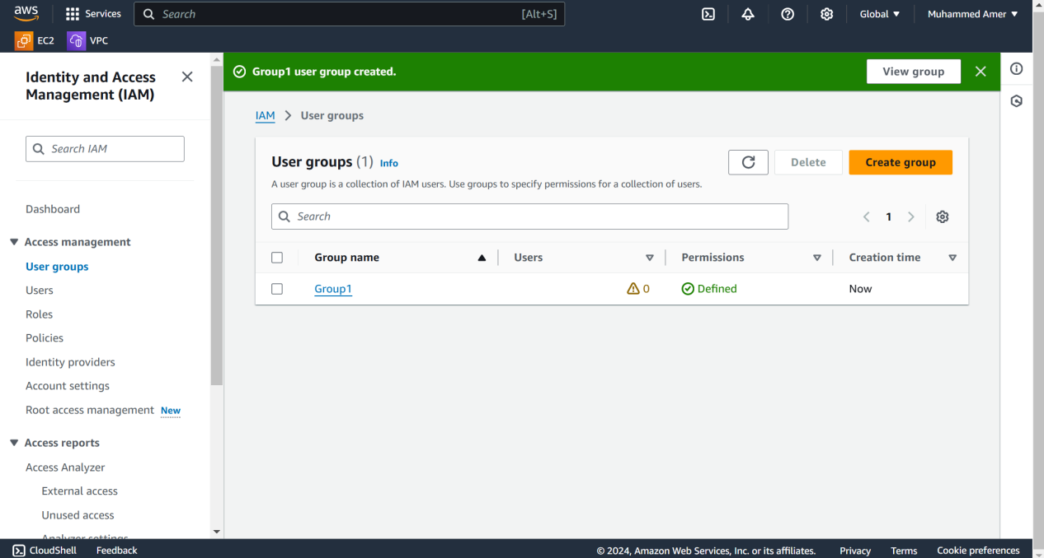

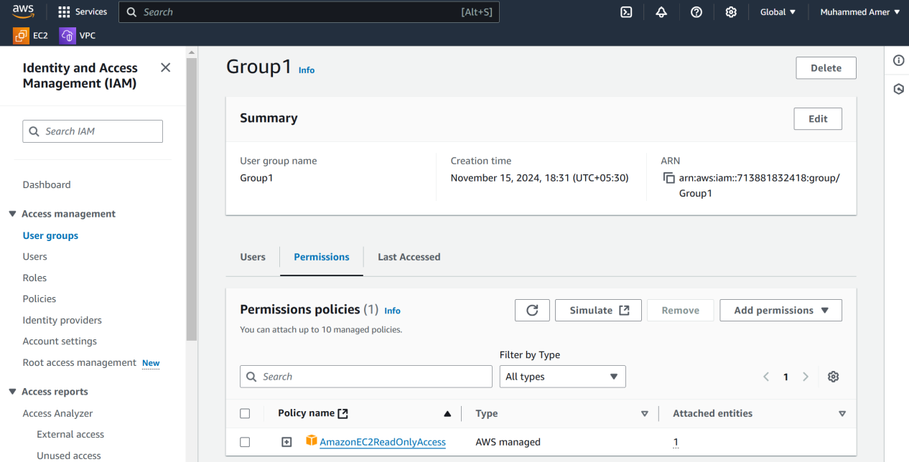

3) Create a new user with name DevOps and add to the group created in task2.   
  
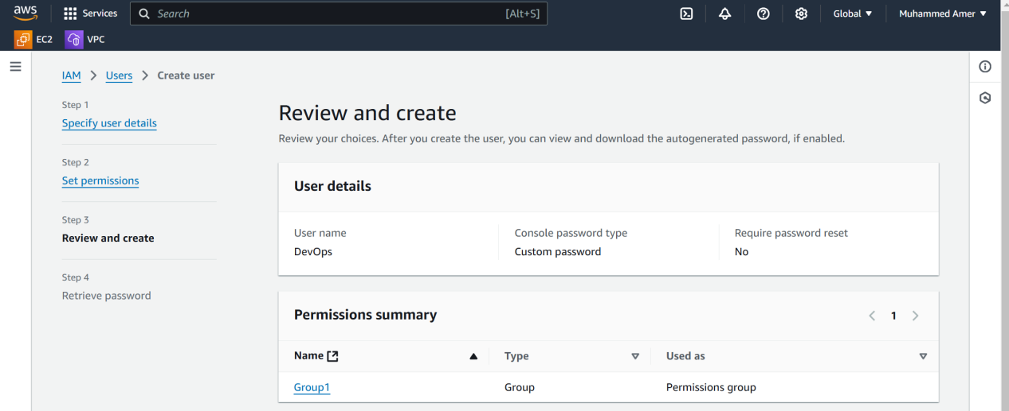

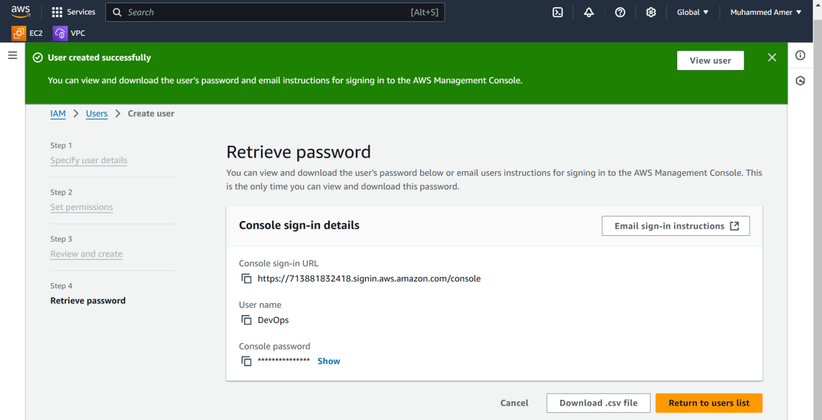  
  
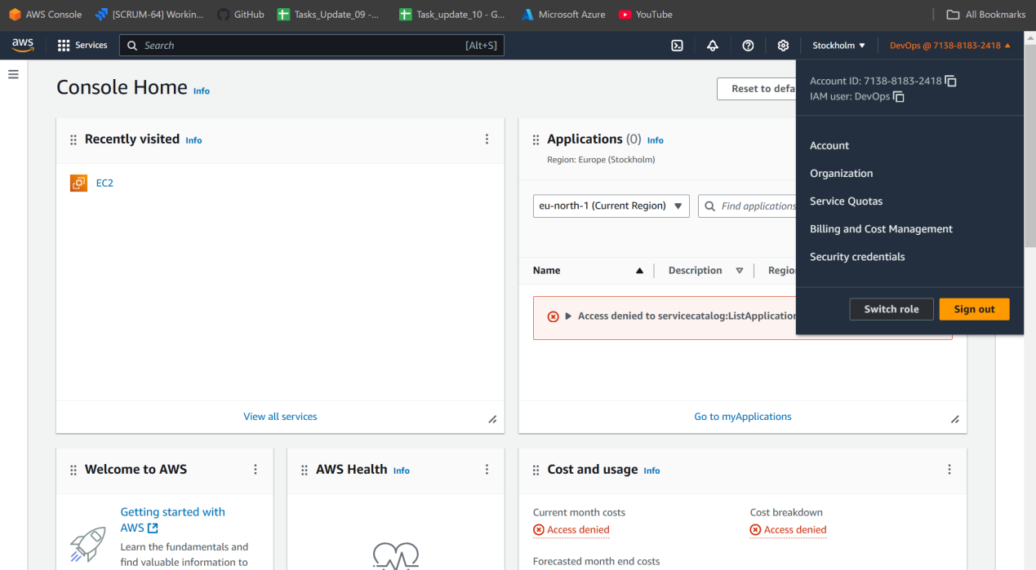  
  
4) Write a bash script to create a IAM user with VPC full access.   
  
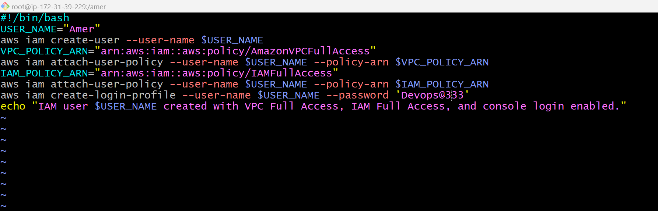  
  
  
  
  
  
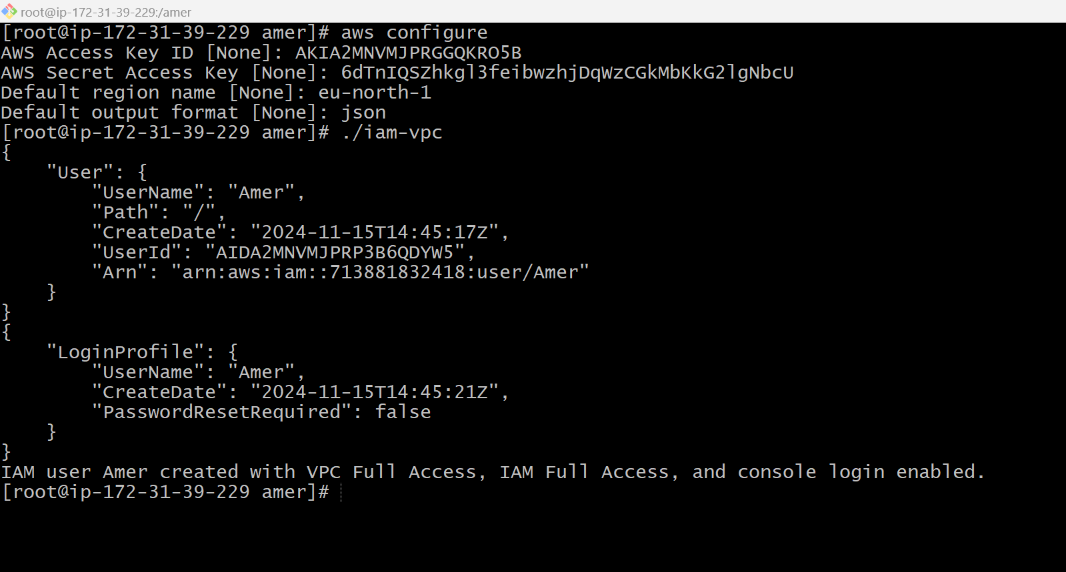

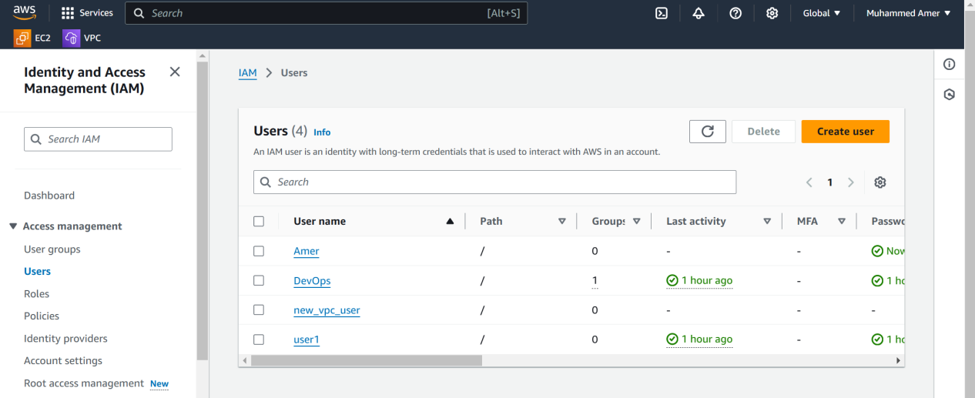

5) Create a IAM policy to access ec2 for a specific user in specific regions only.   
6) We have two accounts Account A and Account B, Account A user should access s3 bucket in Account B. (Collaborate with team member and execute this.Mostly asked in every interview)